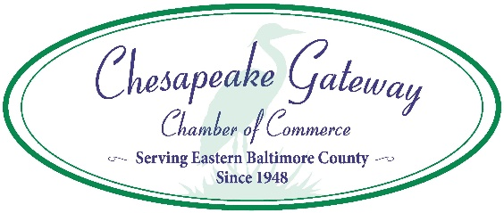
Eastern Baltimore County Task Force Presents:

Essex Farmers’ Market
Essex Park & Ride, 23 Eastern Blvd., Essex, MD
Fridays, June 3 to October 28, 2022, 3:00 to 6:00 p.m., Rain or Shine

VENDOR APPLICATION – DUE MAY 23, 2022

Contact Name: _______________________________ Cell Phone (not for publication): _________________________

Farm/Business Name: _____________________________________________ Phone: __________________________

Physical Address: _______________________________________________ City/State/Zip: ______________________

Mailing Address (if different): _______________________________________ City/State/Zip: _____________________

Email: _____________________________________ Number of Acres Farmed (if applicable): _____________________

Web Address: ___________________________________ Social Media Accounts: ______________________________

List items and/or products you will sell with estimated pricing:
___________________________ _____________________________ _____________________________
___________________________ _____________________________ _____________________________
___________________________ _____________________________ _____________________________

Additional Comments: ______________________________________________________________________________

Request for Space:
Vendor price is $220 for the season for each 10’ X 17’ space (limit of 3 spaces per vendor – if available). Please be certain that you register for enough space for parking your vehicle(s), display and sale. If your vehicle is larger than the space allotment, please contact our office, and we will work to accommodate you.

I would like to reserve _____ spaces at $220 each, for a total of $__________.

Check appropriate box. Receipt will be sent to your email address. In the event that this application is not accepted, and a permit is not issued to applicant, this registration fee will be refunded.
_____ Check enclosed (payable to Chesapeake Gateway Chamber of Commerce)
_____ Please charge my credit card (Visa/Mastercard/Discover/American Express)

Card #: ________________________________________ Exp. Date: __________ CVV: _______ Billing Zip: _________

By signing this application, you verify that the above statements are true and correct and that you are committing to participate for the entire Farmers’ Market season (22 weeks).

Signature: ___________________________________ Date: _______________

For more information or to submit your application, please contact: Sharon Kihn, Sharon.kihn@chesapeakechamber.org, 443-317-8763, c/o Essex Farmers’ Market, Chesapeake Gateway Chamber of Commerce, 405 Williams Court, Suite 108, Middle River, MD 21220. Please include a signed copy of the Rules & Regulations and a copy of pertinent licensing and insurance (including workers’ compensation) with this application.

