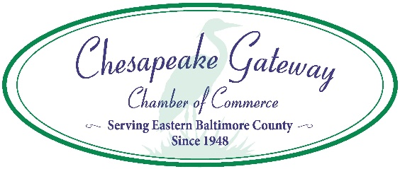
Eastern Baltimore County Task Force Presents:

Essex Farmers’ Market
Parking Lot at SE Corner of S. Taylor & Maryland Avenues
Essex, MD 21221
Fridays, June 4, 2021 to October 15, 2021
3:00 to 6:00 p.m., Rain or Shine

Vendor Release & Indemnification Agreement

For good and valuable consideration, the receipt and sufficiency of which is hereby acknowledged, ___________________________________ (“Vendor”) agrees as follows:
- Vendor agrees to assume all risk of damage to any real or personal property and all risk of personal injury or injury to others arising out of his/her/its participation in the Essex Farmers’ Market (“Market”) or any related activities.

- Vendor agrees to release, indemnify and hold harmless the Chesapeake Gateway Chamber of Commerce, 8725 Acquisition, and their respective officers, directors, employees, agents, consultants, affiliates and volunteers from and against any and all injuries, claims, damages, or causes of action, of any kind or nature whatsoever, including without limitation claims for damage to any real or personal property, personal injury or death, and including all costs and attorney’s fees, arising out of Vendor’s participation in the Market or any related activities.

- This Agreement shall be binding on, and shall inure to the benefit of the Vendor, Chesapeake Gateway Chamber of Commerce, 8725 Acquisition and their respective heirs, successors and assigns.

- This Agreement shall be governed by the laws of the State of Maryland notwithstanding any conflict of law rules.

- By signing below, I hereby certify that I am at least 18 years of age and authorized to execute this agreement, and I acknowledge that I understand, accept and agree to be bound by the terms and conditions set forth in this agreement.
Signed this _____ day of ____________________, 20____
Vendor Name(print): ______________________________________________
Vendor Representative: ____________________________________________
Signature: _______________________________________________________
Return this form along with application to: Sharon Kihn, Chesapeake Gateway Chamber of Commerce, 405 Williams Court, Suite 108, Middle River, MD 21220 or email to: Sharon.kihn@chesapeakechamber.org.

